Fifth Grade Math

iReady Lessons
20 minutes daily either in “My Path” or “Teacher Assigned” lessons

Click here to download the At Home Activity Packet for students who don’t have internet access at home. Use paper and pencil to answer if you don’t have access to a printer.
Day 1:
iReady Math 20 min.
Fraction Skills (adding) Pages 23-24 in Paper Handout Linked above
Day 2:
iReady Math 20 min.
Fraction Skills (subtracting) Pages 25-26 in Paper Handout Linked above
Day 3:
iReady Math 20 min.
Fraction Skills (fractions as division; understanding multiplication) Pages 29-30 in Paper Handout Linked above
Day 4:
iReady Math 20 min.
Fraction Skills (mult. to find area) Pages 31-32 in Paper Handout Linked above
Day 5:
iReady Math 20 min.
Place Value Skills (powers of 10) Pages 4-5 in Paper Handout Linked above

Day 6:
iReady Math 20 min.
Place Value Skills (reading word form, writing standard form) Pages 6-7 in Paper Handout Linked above

Day 7:
iReady Math 20 min.
Place Value Skills (rounding and comparing decimals) Pages 8-9 in Paper Handout Linked above

Day 8:
iReady Math 20 min.
Multiplication Skills (multi-digit including estimating) Page 10 in Paper Handout Linked above

Day 9:
iReady Math 20 min.
Multiplication Skills (encouraging standard algorithm) Page 11 in Paper Handout Linked above

Day 10:
iReady Math 20 min.
Division Skills (estimating and using multiplication to check) Page 12 in Paper Handout Linked above

Fifth Grade ELA
iReady Lessons
25 minutes daily in “My Path” (or “Teacher Assigned” lessons if applicable)
Independent Reading- 20 minutes
This should be any text of student’s choice.
Choose one of the following questions from the box below to complete each day

Resources Below are for those students with no online access:
iReady Take-Home Packet can be accessed by clicking here. Students can answer on a separate paper if a printer is not available.
Day 1: Homographs
I Ready take-home packet p. 11-12
Day 2: Finding theme, understanding vocabulary, summarizing a text
I Ready take-home packet p. 13-14
Day 3: Finding theme, understanding vocabulary, summarizing a text
I Ready take-home packet p. 15-16
Day 4: Finding theme, understanding vocabulary, summarizing a text
I Ready take-home packet p. 15-17
Day 5: Finding theme, understanding vocabulary, summarizing a text
I Ready take-home packet p. 18-19
Day 6: Finding theme, understanding vocabulary, summarizing a text
I Ready take-home packet p. 18-20
Day 7: Prepositions and Prepositional Phrases
I Ready take-home packet p. 21-22
Day 8: Finding theme, understanding vocabulary, summarizing a text
I Ready take-home packet p. 23-26

Day 9: Finding theme, understanding vocabulary, summarizing a text
I Ready take-home packet p. 27-28
Day 10: Review/Assess learned skills
I Ready take-home packet p. 29-31
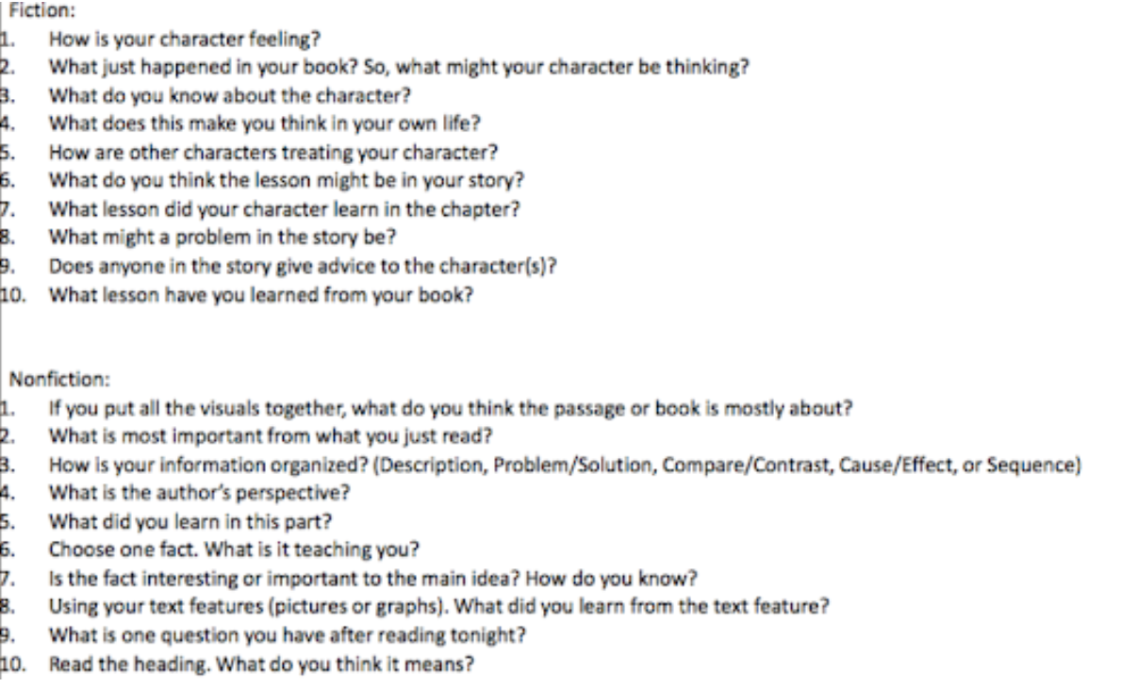

Fifth Grade Social Studies

*Paper Handouts are for students who are unable to access or complete the online portion each day. They can also be used for additional practice with each skill*
Learning Goal
Develop historical awareness by:
● Recognizing how and why historical accounts change over time
● Recognizing how past events and issues might have been experienced by the people of that time, with historical context and empathy rather than present-mindedness
● Identify patterns of continuity and change over time, making connections to the present
Online Learning Activities
https://www.readworks.org/article/United-States-History/e5847a5c-ba50-4ed3-847a-12923ea41640#!contentSection:6781a581-9961-4b17-a9de-2e40c1612731/articleTab:content/
*If student does not have an account, parents can sign up for a free account.
Day 1: Diving into History
Day 2: The Struggle for Equality
Day 3: Walking Tall
Day 4: Eyewitness to History: The Promise of Arthurdale
Day 5: Remembering a Forgotten U.S. President
Day 6: Day of Infamy
Day 7: https://www.readworks.org/article/Talking-Leaves/3a9a5df8-1c27-4d36-8c01-e8344d73e834#!questionsetsSection:925/answerKey:false/articleTab:content/
Talking Leaves - read
Day 8: Talking Leaves - question set
Day 9: https://www.readworks.org/article/The-Fight-for-Womens-Suffrage/6ce8b52e-da5d-4b5c-9f0d-19fd0510b6e2#!questionsetsSection:20252/answerKey:false/articleTab:content/
The Fight for Women’s Suffrage - read
Day 10: The Fight for Women’s Suffrage - question set

Alternative activities for students without internet access at home

Students will read the article and then write 2 or 3 things that they learned from the article and would like to remember in their journal.
Day 1:
Read Article 1 - Diving into History; Journal entry
Read Article 2 - The Struggle for Equality; Journal entry
Day 3:
Read Article 3 - Walking Tall; Journal entry
Day 4:
Read Article 4 - Eyewitness to History: The Promise of Arthurdale; Journal Entry
Day 5:
Read Article 5 - Remembering a Forgotten U.S. President; Journal Entry
Day 6:
Read Article 6 - Day of Infamy; Journal Entry
Day 7:
Read Talking Leaves
Day 8:
Talking Leaves question set
Day 9:
Read The Fight for Women’s Suffrage
Day 10:
The Fight for Women’s Suffrage questions set

Fifth Grade Science

https://www.weareteachers.com/5th-grade-science-projects/

Choose some of these science projects to complete at home. Describe the process and results in your learning journal.

Fifth Grade “Off-line” Activities

Fifth Grade ELA
Monday:Read a book of your choice for 20 minutes. After reading the text, think about the theme. What big idea did the author want you to learn from the story? After determining the theme, write a summary of the text that includes the most important details to support the theme.

Tuesday: Create a “Wanted” poster for a villain in either a book or fairy tale you’ve read. Draw a picture of the villain then provide a physical description and explain the crimes committed. What reward would you offer for the villain’s capture

Wednesday:Read a book of your choice for 20 minutes. After reading the text, use speech bubbles and pictures of the characters to draw a conversation between two characters from the story you have been reading. Remember a thought is drawn as a cloud and a spoken statement is drawn as a bubble.

Thursday: Read a book of your choice for 20 minutes. After reading the story, classify various sentences (at least 10) into three categories: simple, compound, and complex. After making your lists, try to write each type of sentence on your own using those from the story as models.

Friday: Write about what you did throughout the day. Include feelings such as happiness, excitement, or frustration about the daily tasks. Draw a picture to support your writing.

Fifth Grade Math
Monday: Create 1 word problems using addition, 1 word problem using subtraction, 1 word problem using multiplication and 1 word problem using division.

Tuesday: You have $1.00 in change in your pocket. You have 15 coins. What coins do you have?

Wednesday: Ask your child to make equivalent amounts in other coins for a given number of pennies. For example, if you have 135 pennies, the student could make an equivalent amount using one dollar and 35 pennies, or 13 dimes and 5 pennies, or one dollar, 3 dimes and 5 pennies.

Thursday: Create 2 multi-step word problems using addition, subtraction multiplication and/or division.

Friday: Make up your own math riddles for each other. For example, Start at 39. Subtract 4, divide by 7, and add 6. What is the mystery number?

