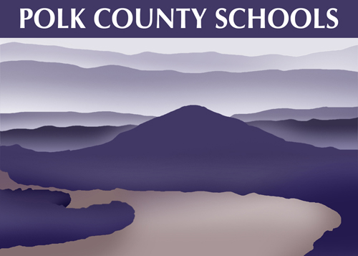

“Learning for a Lifetime”
______________________

Department of Education
131 Stephens Street
P.O. Box 665
Benton, Tn 37307

Ph. 423-299-0471
Fax: 423-338-2691
www.polk-schools.com

Dr. James R. Jones
Director of Schools

____________________________

Dear Polk County Families,

The changes to our lives because of the COVID-19 Pandemic have affected us all.
As we look forward to school starting in August, we would like to inform parents of the educational options available this year.

Regular: Students are in-person and in school every day with a teacher in place. This is the traditional way we have always had school. Students are “learning at school.”

Remote Learning: Students are “learning at home”, with a teacher helping coordinate on-line learning or another form of learning designed by the teacher. This option can be selected for a minimum of 2 weeks at a time. The student remains enrolled in his or her regular school and may move back and forth between the two options during the school year. Remote Learning enrollment is not limited. You will find Remote Learning enrollment forms on your school Facebook page and on the individual school pages at www.polk-schools.com.

PILA- Polk Innovative Learning Academy, designed by Dr. Tamra Lanning. PILA is our Virtual School serving grades K-11, with students using an online curriculum that is aligned with TN standards. Students who enroll in PILA are only allowed to switch back to their regular brick and mortar school at the end of the semester. Enrollment is limited to 150 students. For PILA enrollment, go to https://www.polkvirtual.com/admissions

Each of these plans are designed to have assignments graded and attendance required and monitored.

For students choosing the “Regular” schooling method, we have planned for staggered attendance for the first two weeks of school:

August 10-14 (Week 1)
For this week we will have an A/B/C/D rotation for students to attend school. A different group comprised of approximately 25% of the school’s enrollment will attend each day. Monday, Tuesday, Thursday, and Friday will be in-school days. Wednesday will be a day for teachers to connect virtually with ALL of their students to deliver instruction and to prepare lessons. You will be notified by your school which day you should attend.

August 17-21 (Week 2)
For the second week of school we will have an A/B rotation, with 50% of the students coming on Monday (A) and Tuesday (B). Wednesday will be connecting with all students. Then we will repeat the 50% school attendance for Thursday (A) and Friday (B).

August 24-31
All students who are not enrolled in Remote Learning will be attending school every day unless further changes are necessary.

All students must be taught every day (State Department of Education requirement), but there will only be 25% or 50% of the students in the classroom for the first two weeks of school. This will be a “Learn from School” or a “Learn from Home” model.

Your principals will be dividing the students up by families so siblings can come on the same day. Principals will notify parents about which days their child(ren) will attend school.

Whichever option is chosen by your family, our Food Services department will continue to provide nutritious breakfasts and lunches. Details about the breakfast and lunch program for the 2020 school-year will be coming in our next information segment.

Our schools will be offering training on Google Classroom for parents during the first week of August since that will be our platform for online learning to start school. Every family choosing the REMOTE option is strongly encouraged to attend the training for Google classroom. Dates and times for training will be communicated to parents before August 3rd. We will continue to offer lessons throughout the school year as needed. Instructional videos and user guides to help parents with the Remote Learning technology will be posted on our district website.

https://www.polk-schools.com/learning-at-home

We know this will be a stressful time for all, and we will work together to do our best for the students of Polk County. We appreciate you and recognize what an important role parents and caregivers will play in making this school year the best it can be.

Sincerely,

Dr. James R. Jones
jjones@polkcountyschools.com

